Blue Room Summer Camp

Topic: Energy Teachers: Vera Wiest and Timisa Johnson Date: 7/2/2018
Monday | Tuesday |  | Wednesday | Thursday |  | Friday
Project Meeting  Today we will begin learning about light energy! | Project Meeting  Today we will go on our first field trip to the Leaf House!  We will also explore how our bodies are like firecrackers! |  | Project Meeting  CYC Closed for 4th of July | Project Meeting  Today we will explore solar energy with solar powered cars! |  | Project Meeting  Let’s use our knowledge on solar energy to create solar ovens!
Daily Writing  What did you do over the weekend? | Daily Writing  What are two things you learned at our field trip today? |  | Daily Writing  N/A | Daily Writing  How did you spend your 4th of July holiday? |  | Daily Writing  What would you change to make the solar ovens better?
Language Arts: We will read folktales from Grandmothers’ Stories, retold by Burleigh Muten.  Water Table: Shovels and measuring cups will be available at the water table this week!  Gross-Motor Skills Game: This week we will have a math bean bag toss game outside! |  | 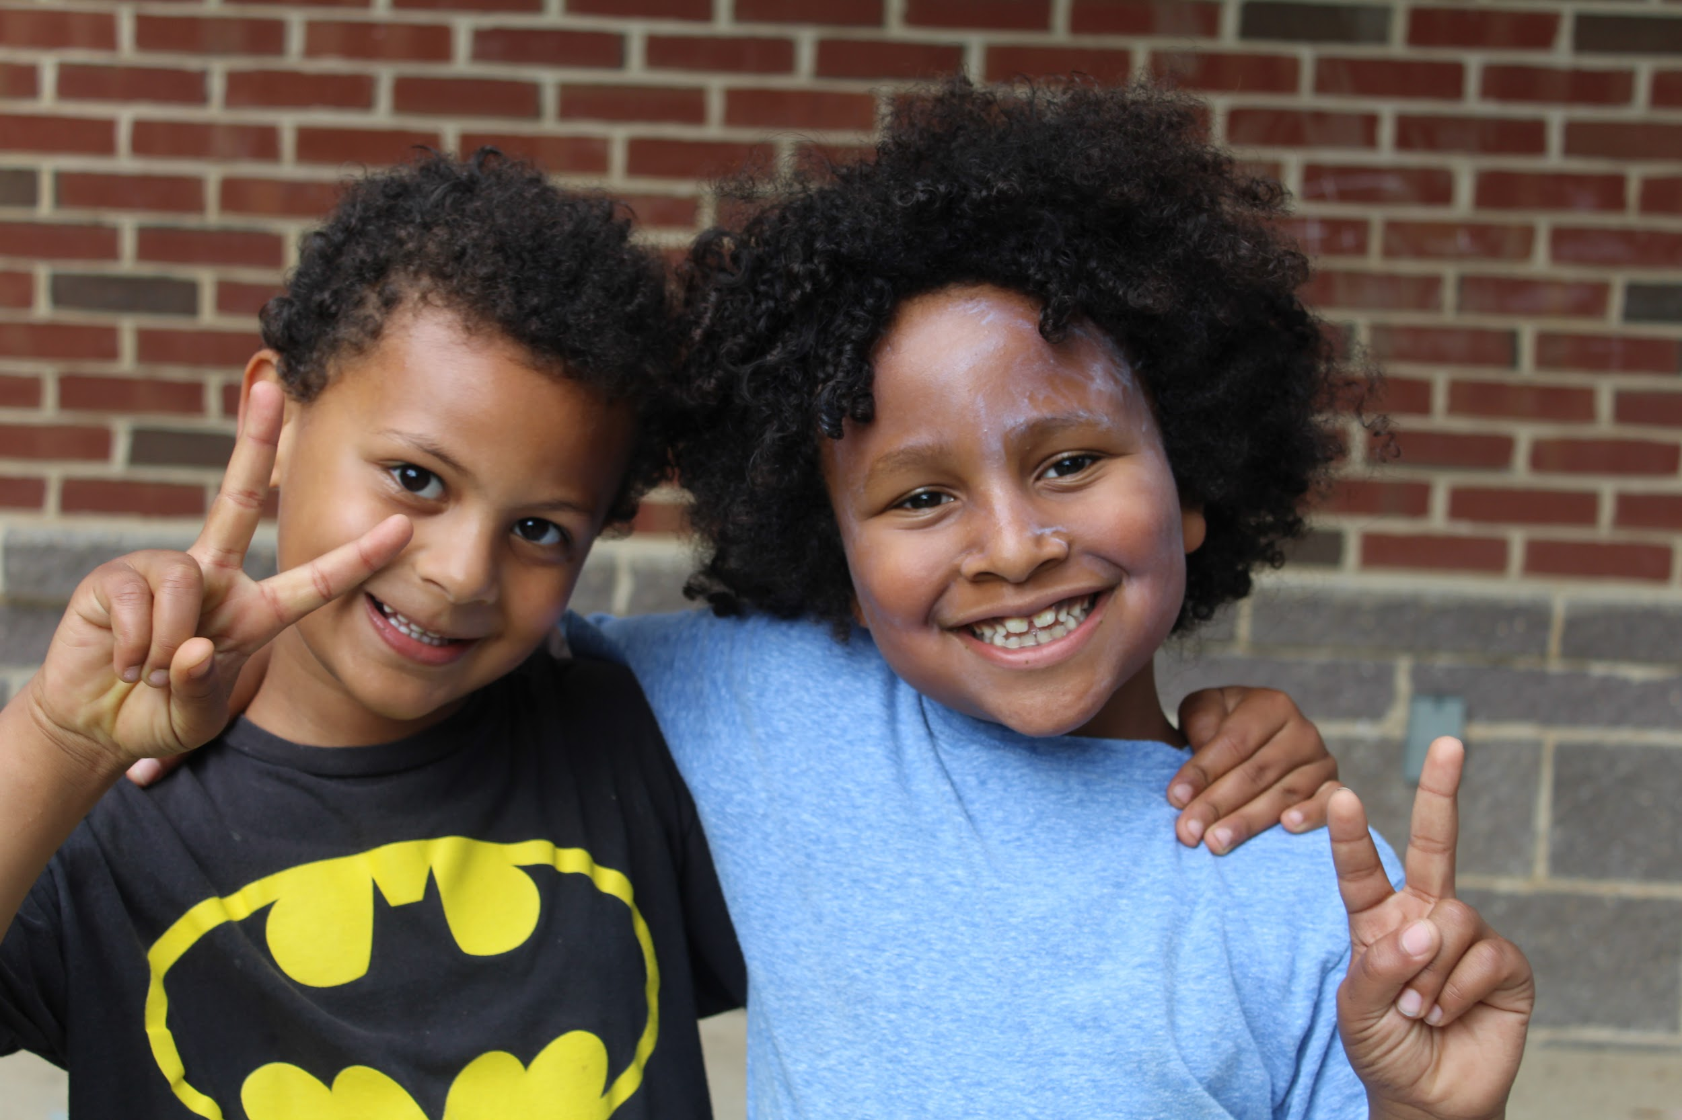 |  |  | Math: This week in math, we will begin graphing the heat index!  Cooking: We will do a 4th of July inspired cooking project.  Art Table: We will have colored tape, ribbon, fabric, and yarn available at the art table this week!  Light Table: The light table will be available this week
Reminder:
- We will go to the pool Thursday and Friday this week. Please send your child to school in their swimsuit and bring a change of clothes. Also, if you are available, please sign up to chaperone a day at the pool!
- Music will be on Mondays from 9:30-10:00 a.m. We will also have music with instruments on Tuesdays from 3:15-3:45 p.m.
- CYC is closed Wednesday, July 4th in observance of the 4th of July holiday.

